A PROJECT REPORT

ON

**RFID BASED ATTENDENCE SYSTEM**

Submitted By

**NAME OF CANDIDTES**

Aarti Sharma

Ayush Gupta

Prachi Chaudhary

Yukti Arora

**Under the Guidance of**

**Prof. Umesh Dutta**

**DEPUTY DIRECTOR**

in partial fulfillment for award of the degree of

**BACHELOR OF TECHNOLOGY**

**IN**

**ELECTRONICS AND COMMUNICATION**



**Manav Rachna University, Faridabad**

**JUNE,2018**

**ACKNOWLEDGEMENT**

We would like to express our sincere gratitude to our project guide "**Mr. Umesh Dutta**" for giving us the opportunity to work on this topic. It would never be possible for us to take this project to this level without his innovative ideas and his relentless support and encouragement.

1. Ayush Gupta
2. Aarti Sharma
3. Prachi Chaudhary
4. Yukti Arora

**CERTIFICATE**

**TABLE OF CONTENTS**

**LIST OF FIGURES**

**LIST OF TABLES**

08 **ABSTRACT**

08 **INTRODUCTION**

**MOTIVATION**

The present attendance taking systems are very time consuming. They require the attendance taker to be very careful while marking the attendance since chances of manual errors and proxy are very high.

To overcome these problems and to make the attendance taking system more efficient and quick this project is developed.

**PURPOSE**

This project is aimed to replace the existing manual attendance taking system by RFID (Radio frequency Identification) based attendance system to reduce the chances of manual errors while marking the attendance.

It also reduces the chances of proxy (fake attendance) to a large extent. It’s a kind of justice to the students as the students who are present will only be marked present rather than those who are not.

This project provides transparency to the entire system which is needed nowadays and many fields lack this type of attendance system. The attendance once marked cannot be tempered. This project provides ease to both attendance taker and students/employees saving their time. It also introduces students to new technology and new components and allows the maximum possible use of developing technology.

**FUNCTIONING**

This project requires all the students/employees of the institute to have a RFID (Radio Frequency Identification) card (tag) provided by the institute. This card has a unique 12-digit number.

While taking the attendance, the student is required to bring the card in the vicinity of the RFID reader module, the card then sends the number to the reader module. This number is directed to the Arduino where it is compared with the numbers of all the students on the class list.

If it matches any of those numbers then the attendance of the corresponding student is marked. The students who haven't scanned their cards will be marked absent. If the fetch button is pressed then the names of the absent students will be displayed on the LCD.

The list of the absent students same be sent to the app via Bluetooth. The same list of the absent students will be sent to the concerned person (mentor).

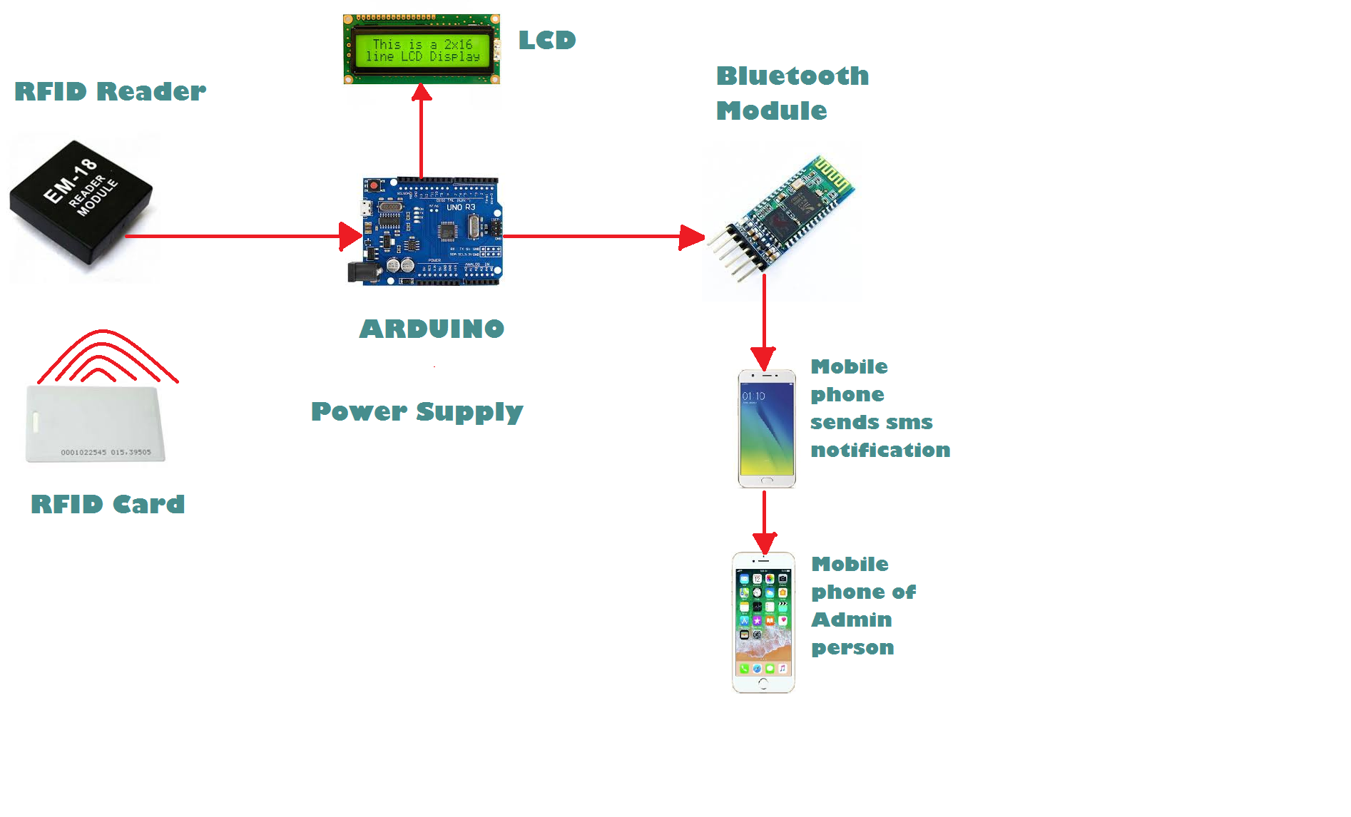

Fig 8.1 Block Diagram

09 **CHARTS**

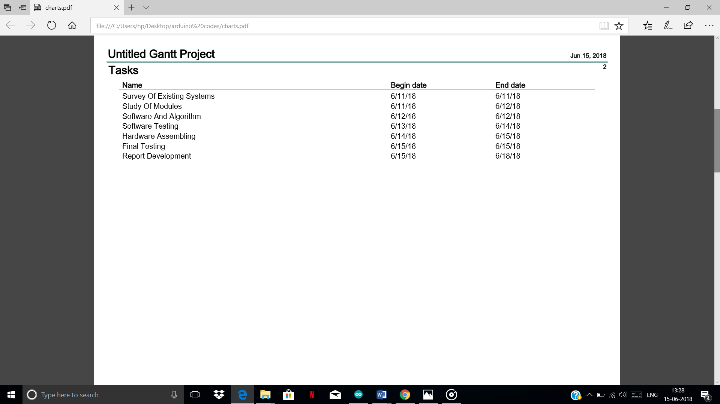

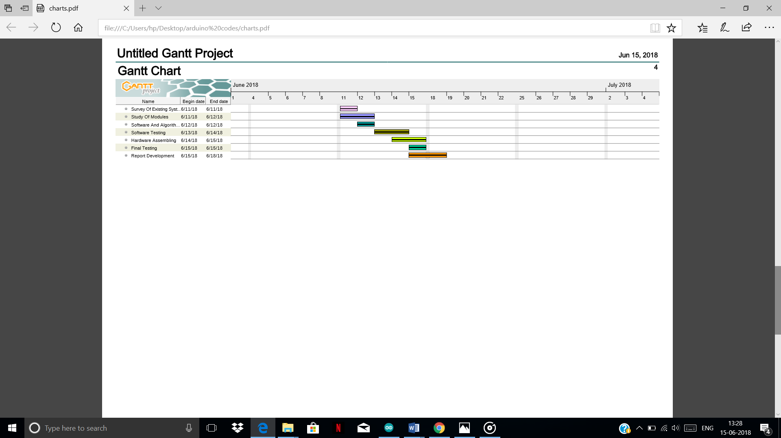Gantt Chart

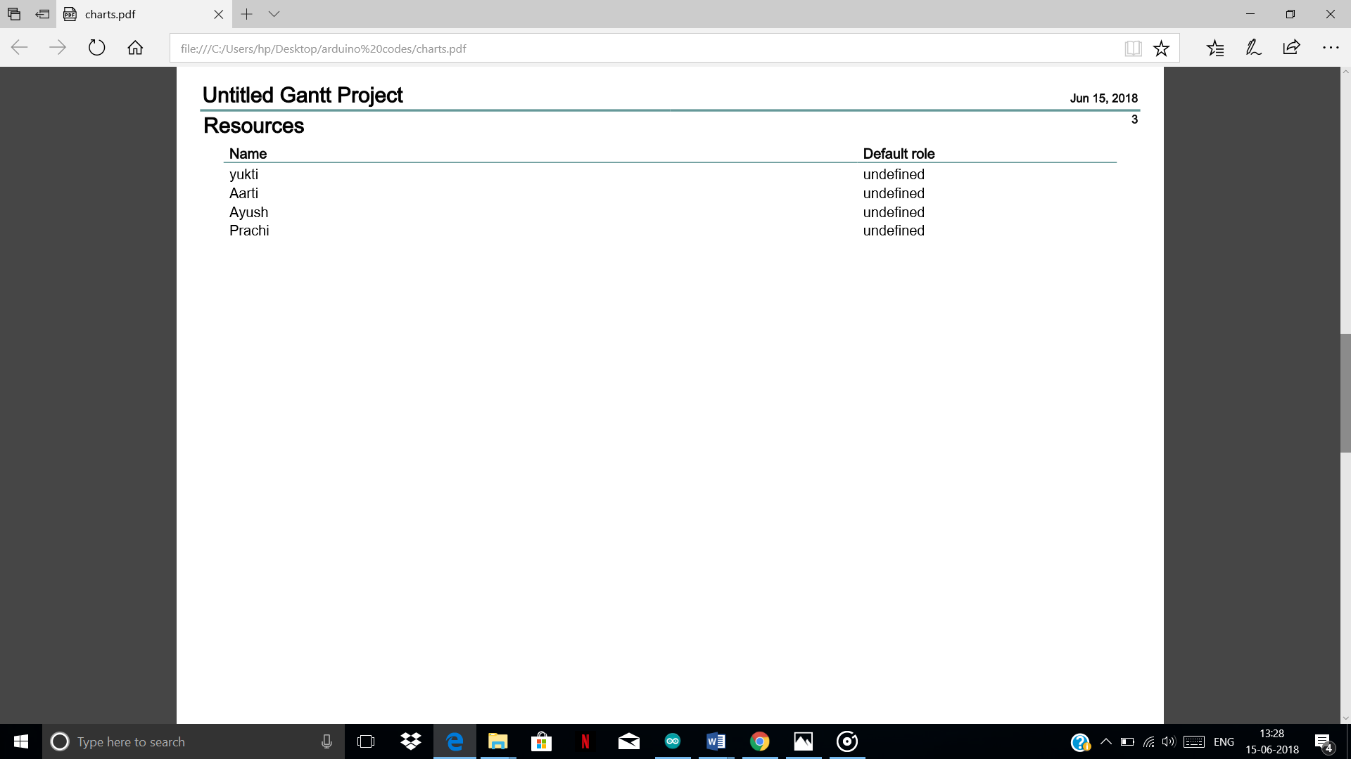

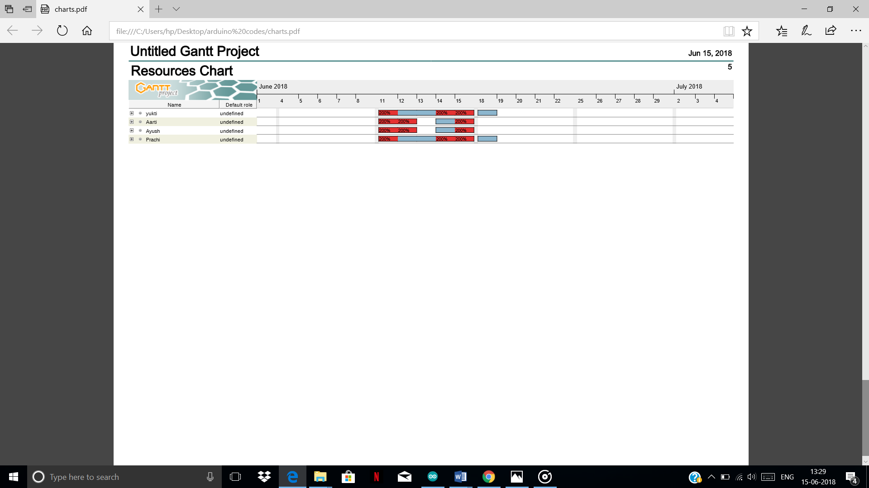

Resource Chart

10 **THEORY**

10.1 **LCD**

LCD is also defined as Liquid Crystal Display  is the technology used for displays in various digital devices. These Liquid Crystal Displays are cost effective, consume less power and are also very easy to handle or carry.

The information or Data that is to be displayed in the LCD can also be changed accordingly with great ease. LCD is widely used to display text messages and are most commonly used in Embedded system applications. It is also used in screens for mobile devices, such as [laptops](https://techterms.com/definition/laptop), tablets, vending machines and  [smartphones](https://techterms.com/definition/smartphone) .

Each LCD screen contains a matrix of pixels that display the image on the screen. That can be a 16x 2 display or 20x 4 display and many more. 16x2 is the most widely used LCD display here 16x2 indicates that there are 2 rows and, in each row, there are 16 characters.

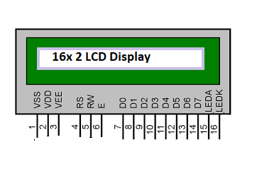

Fig10.1 16 X 2 LCD

**Features of 16×2 LCD module**

* LCD Display can display alphabets and Numbers.
* Consists of two rows and each row has 16 characters.
* It can work on both 8-bit and 4-bit mode Depending upon the library.
* Available in Green and Blue Backlight.

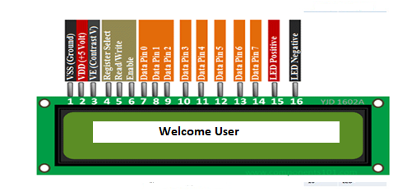

Fig10.2 Pin Configuration

|  |  |  |
| --- | --- | --- |
| **Pin num.** | **Pin Name.** | **Description of pin** |
| 1 | VSS (Ground) | This pin is connected to the System Ground. |
| 2 | VCC (+5 V) | This pin supplies voltage connected to +5V. |
| 3 | VEE (V) | This is used for defining the contrast of the LCD Display. It is Grounded to get maximum contrast or potentiometer can be used to adjust the contrast. |
| 4 | Register Select(RS) | This Shifts between command/data register. |
| 5 | Read/Write(R/W) | * Used to read or write data. * If R/W=0 Write operation is selected(Ground). * If R/W=1 Read operation is selected |
| 6 | Enable(EN) | This pin is used to push data. Generally, it remains low. But for execution of Data we make it High |
| 7 | DB0 | Data pins 0 to 7 forms an 8-bit data line.  These LCD’s can also operate on 4-bit mode using the upper 4 bits those are from Data Pin 4 to Data Pin 7. |
| 8 | DB1 |
| 9 | DB2 |
| 10 | DB 3 |
| 11 | DB 4 |
| 12 | DB5 |
| 13 | DB6 |
| 14 | DB7 |
| 15 | LED + | Backlight LED pin (+5 V) |
| 16 | LED - | Backlight LED pin (Grounded pin) |

Table 10.1

**RS, R/W, EN** pins are also called as **control lines**. After that come the Data lines from **DB0 to DB7** followed by the LED +ve and – ve terminals.

10.2 **ARDUINO**

Arduino is an open-source platform i.e. can be used by people easily or freely for building their projects. It consists of a microcontroller and a piece of software or IDE (Integrated Development Environment).

The Uno is one of the most popular boards in the Arduino family and the beginners must always go for Arduino UNO.

Arduino makes several different boards, each with different capabilities.

But in This project, we will be using Arduino UNO for connections.

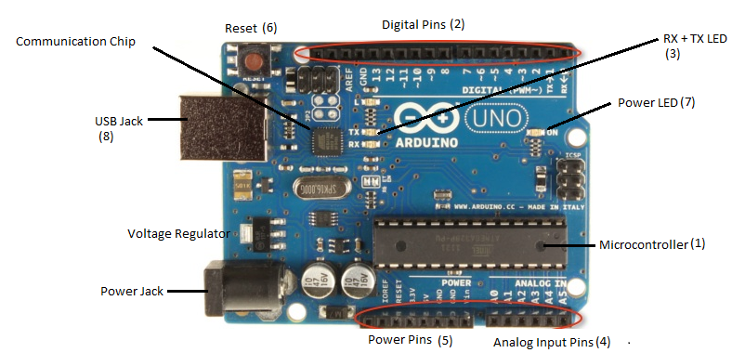

Fig 10.3 Arduino UNO

### Power(USB/Jack)

Power or USB Jack is the source through which Arduino is connected to the power supply. It can also be connected to the USB cable of our computer or the power supply from Switches.

### Voltage Regulator

### The function of the voltage regulator is to control the voltage given to the Arduino board.

**Reset**

We can reset Arduino board or, start the program from the beginning. It can be done by using the reset button (on the top) on the board or also by connecting an external reset button with the RESET pin of Arduino.

**Analog pins**

Arduino board has five analog pins A0 to A5. These pins can read the signal from analog sensor and convert it into a digital value that can be read by the microprocessor.

**Power Pins**

It consists of total of 5 pins including Ground Pins, Voltage Supply (3.3 V & 5V) Pins, Power pin through which LCD can be connected.

**Microcontroller**

It is considered as the brain of the system where all the information’s are stored. The main IC is always Different from Board to Board which has to be specified.

**Power LED**

This LED must light up when Arduino is given Power Supply. If the light does not turn on, then there is something wrong with the connection or there is error in the code.

**Digital Input /Output**

There are 14 Digital Input / Output pins. These pins can be used for both digital input and digital output.

**TX/RX**

TX is short for transmit, RX is short for receive. There are two places on the Arduino UNO where TX and RX appear – once by digital pins 0 and 1 which are set as default (0,1). The default can also be changed by using the default library.

10.3 **HC-05 Bluetooth Module.**

Bluetooth Module can be defined as a module used to transfer data through Bluetooth. There is different type of Bluetooth modules, but in this Project, we are Using HC-05 Module, this is an easy to use module designed for wireless serial connection setup.

**Specification:**

1. Input Voltage: DC 5V.

2. Communication Method: Serial Communication.

3. Master and slave mode can be switched i.e. the receiving and transmitting processes.

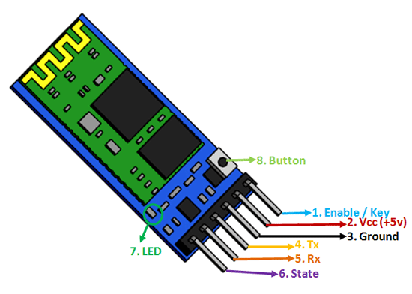

Fig 10.4 Pin Configuration

|  |  |  |  |  |
| --- | --- | --- | --- | --- |
| **Pin Num.** |  | | **Name of pin** | **Description of pin** |
| 1 |  | | Enable / Key | This pin is used to push data. |
|  |
| 2 |  | | VCC | It is the power module Connect to +5V Supply voltage |
|  |
| 3 |  | | Ground | It is the ground pin, connect to system ground. |
|  |
| 4 |  | | TX – Transmitter | Everything received via Bluetooth is transmitted or given out by this pin. This pin is connected to RXD of the microcontroller |
|  |
| 5 |  | | RX – Receiver | Every serial data given to this pin is received via Bluetooth. This pin is connected to TXD of microcontroller. |
|  |
| 6 |  | | State | This pin is connected to the LED, it is used to check if Bluetooth is working properly. Weather it glows properly or not. |
|  |
| 7 |  | | LED | Shows that if the Bluetooth module is connected or not to the device.  1.Blink once in 2 secs: Bluetooth is connected.  2.Repeated Blinking: this means that the Bluetooth is not connected. |
| 8 | |  | Button | Used to control the Enable pin. |

Table 10.2

10.4 **RFID Reader**

RFID stands for (radio frequency identification) it refers to technologies that use wireless communication between an object and a tag used. It is most widely used as access control system. This card works on 2 formats access denied and access allowed basis. If the card is brought near to the reader and the value is store in the back hand or data base then the access is allowed else access denied.

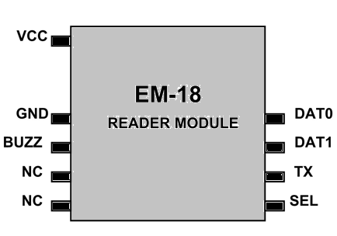

Fig 10.5 Pin Configuration

It is a nine-pin device. Among nine pins, 2 pins are not connected written as (NC & NC), hence we have to consider seven terminals.

|  |  |
| --- | --- |
| **Pin Number** | **Description** |
| VCC | Connected to positive power source |
|  |
| GND | Is connected to ground. |
|  |
| BUZZ | Is connected to BUZZER |
|  |
|  |
| NC | Not connected |
| NC | Not connected |
|  |
| TX | DATA is given out through TX of RS232 |
|  |
|  |  |

Table 10.3

10.4 **RFID Card**

It is a type of card that transfers its content via RFID reader. Each card has its own 12 Digit number.

There are two type of RFID cards namely passive RFID card and active RFID card. Active RFID cards are those which have their own power source they have their own signal and have much longer range as compared to passive ones. Passive RFID cards are those which have no battery connected they come into action only when brought near to RFID Reader. They have a range of approx. 10 cm also these tags are cheaper as compared.

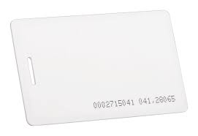

Fig 10.5 RFID Card

10.5 **Jumper Wires**

Jumper wires are also called as the connecting Wires used for connecting the circuit or with the bread board. There Are 3 types of Jumper Wires there are as follows:

* Male-male
* Female-Female
* Male-Female

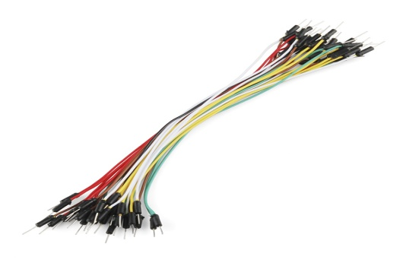

Fig 10.6 Jumper Wires

11 **CIRCUIT DIAGRAMS**

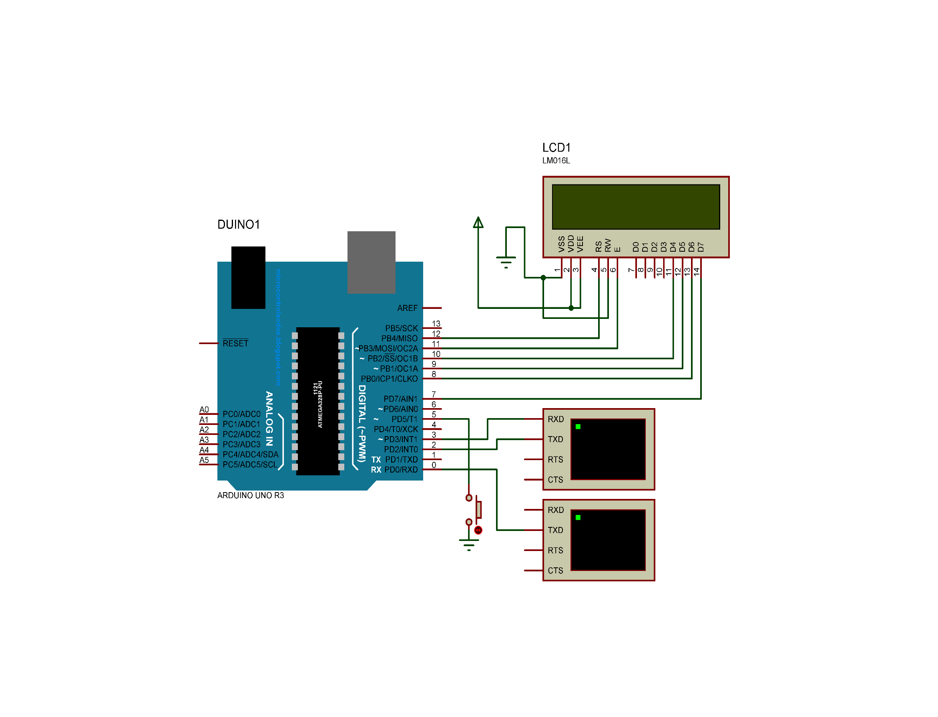

12 **ALGO & FLOW CHART**

12.1 **Algo for LCD**

1. Define the pin of Arduino to be used for LCD.(LiquidCrystal())
2. Define the type of LCD i.e. rows and columns
3. Set the cursor from where the data is to be displayed.
4. Print the Message to be displayed.

12.2 **Algo for RFID**

1. Declare a variable temp of string type.
2. While (data not available)
   1. reads the data.
   2. Store the data in variable temp
   3. Print temp in LCD.

12.3 **Algo for Final CODE**

1. Initialize two arrays
2. Store the names of the students in array1
3. Initially mark absent of all the student in array2
4. Store the numbers of rfid cards of all the students in different variables(std1,std2……).
5. Now store the number of RFID card flashed, in a variable temp
6. If(temp matches any of the variables(std1,std2…..)
   1. Mark present of the corresponding student in array2
7. take a list of all the students marked absent and print it on LCD.
8. Send the same list using Bluetooth device to phone

13.1 **CODE FOR ARDUINO**

#include <LiquidCrystal.h>

#include <SoftwareSerial.h>

#include <String.h>

SoftwareSerial mySerial(2,3); // 2- rxd 3-txd

LiquidCrystal lcd(12,11,10,9,8,7);

String temp;

String emp1="13006F9B9176";

String emp2="8400811FA0BA";

String emp3="120088F3EA83";

String emp4="55000CAAAE5D";

int len;

String total[4]={"Aarti","Ayush","Prachi","Yukti"};

int present[4]={0,0,0,0};

int i;

String bt="*";

void my_init()

{

lcd.begin(16,2);

lcd.setCursor(5,0);

lcd.print("Welcome");

lcd.setCursor(7,1);

lcd.print("User");

}

void setup()

{

Serial.begin(9600);

mySerial.begin(9600);

lcd.begin(16,2);

pinMode(6,OUTPUT);

pinMode(5,OUTPUT);

digitalWrite(6,LOW);

digitalWrite(5,HIGH);

}

void loop()

{

lcd.clear();

lcd.setCursor(5,0);

lcd.print("Welcome");

lcd.setCursor(7,1);

lcd.print("User");

lcd.setCursor(0,0);

if(digitalRead(5)==HIGH)

{

//while(!Serial.available());

if(Serial.available()>0)

{

temp=Serial.readString();

}

//a

if(temp==emp1)

{

lcd.clear();

lcd.setCursor(0,0);

lcd.print("Aarti");

delay(1500);

my_init();

present[0]=1;

temp="000000000000";

}

//b

else

if(temp==emp2)

{

lcd.clear();

lcd.setCursor(0,0);

lcd.print("Ayush");

delay(1500);

my_init();

present[1]=1;

temp="000000000000";

}

//c

else

if(temp==emp3)

{

lcd.clear();

lcd.setCursor(0,0);

lcd.print("Prachi");

delay(1500);

my_init();

present[2]=1;

temp="000000000000";

}

//d

else

if(temp==emp4)

{

lcd.clear();

lcd.setCursor(0,0);

lcd.print("Yukti");

delay(1500);

my_init();

present[3]=1;

temp="000000000000";

}

}

if(digitalRead(5)==LOW)

{

for(i=0;i<4;i++)

{

if(present[i]==0)

{

lcd.clear();

lcd.setCursor(0,0);

lcd.print("Students Absent");

lcd.setCursor(0,1);

lcd.print(total[i]);

bt+=i;

bt+=',';

delay(2000);

}

}

len=bt.length();

bt.remove(len-1);

mySerial.print(bt);

mySerial.println("#");

}

delay(2000);

digitalWrite(6,LOW);

}

13.2 **CODE FOR APP**

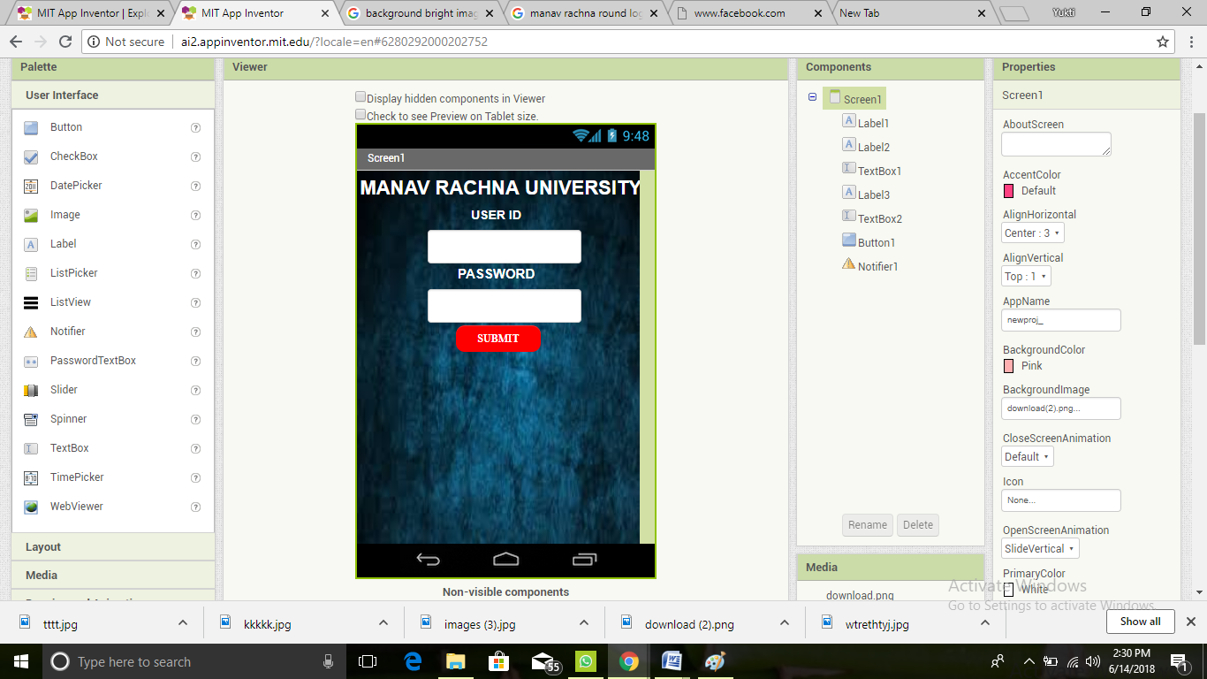

Layout of start page of app

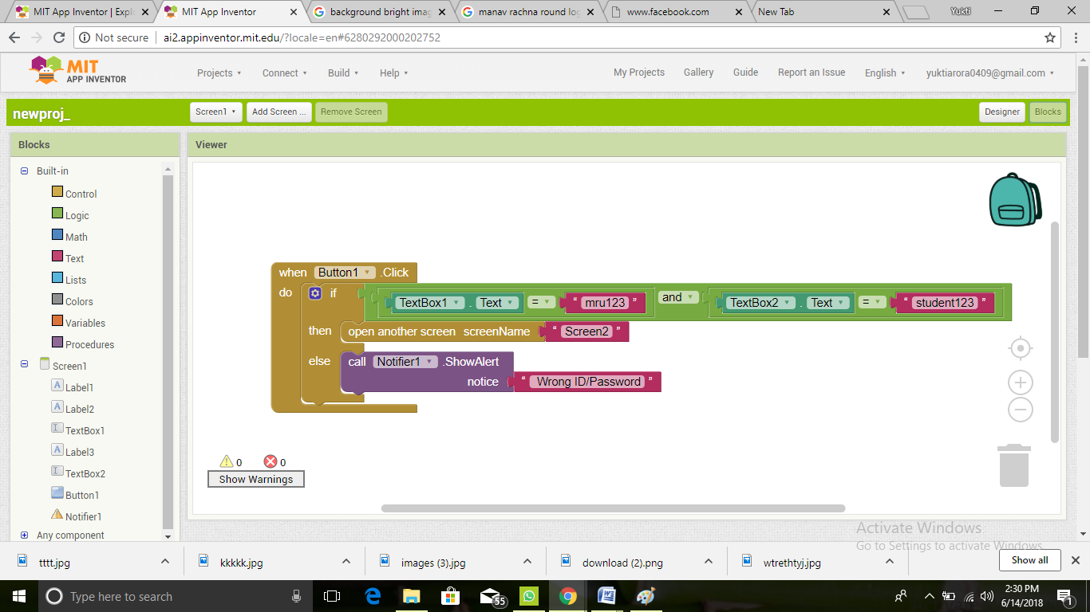

Code for start page

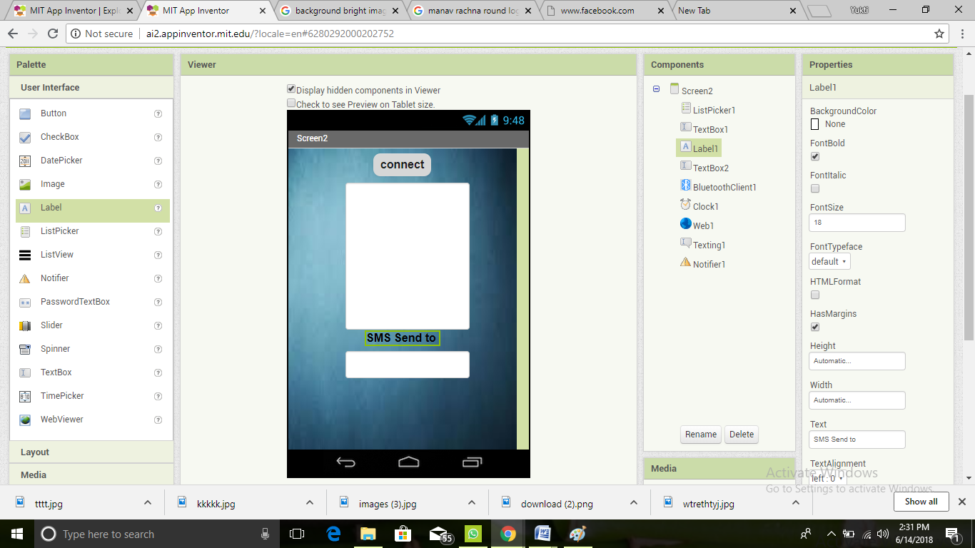

Layout of main page of app

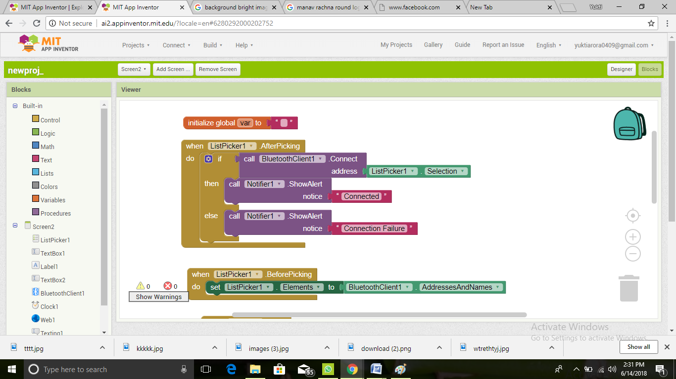

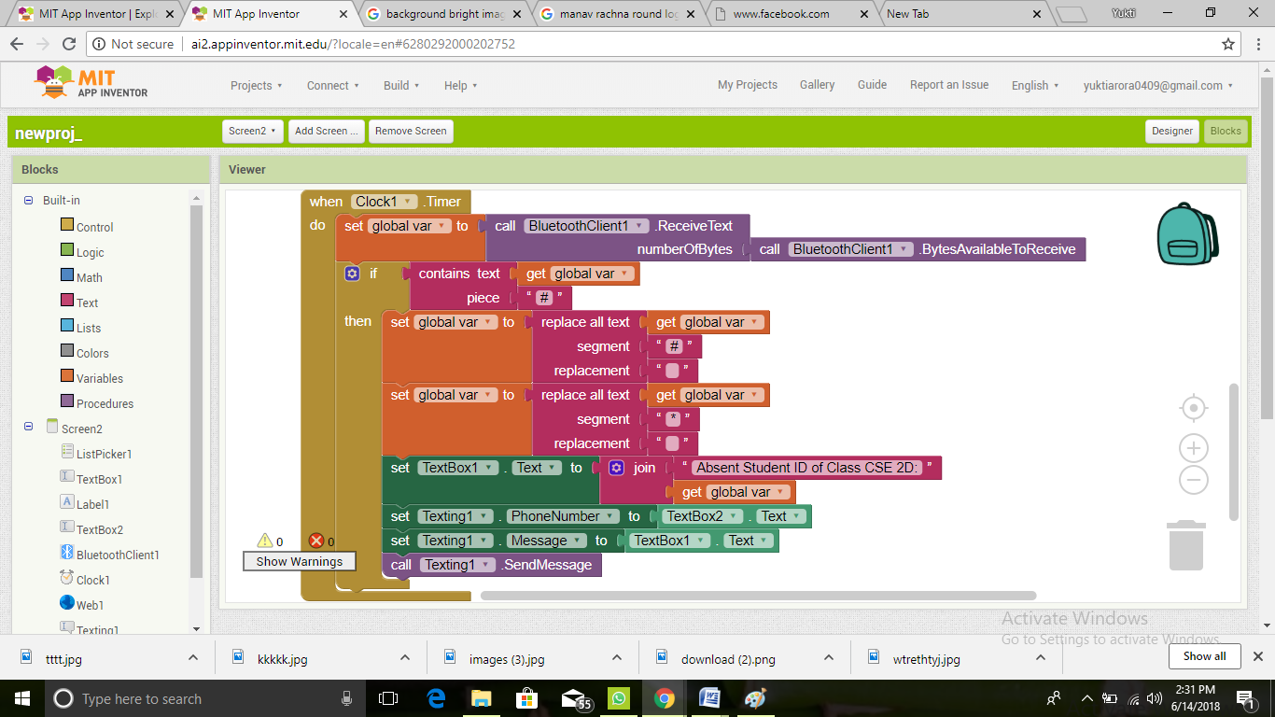

Code main page

14 **STIMULATION TESTING**

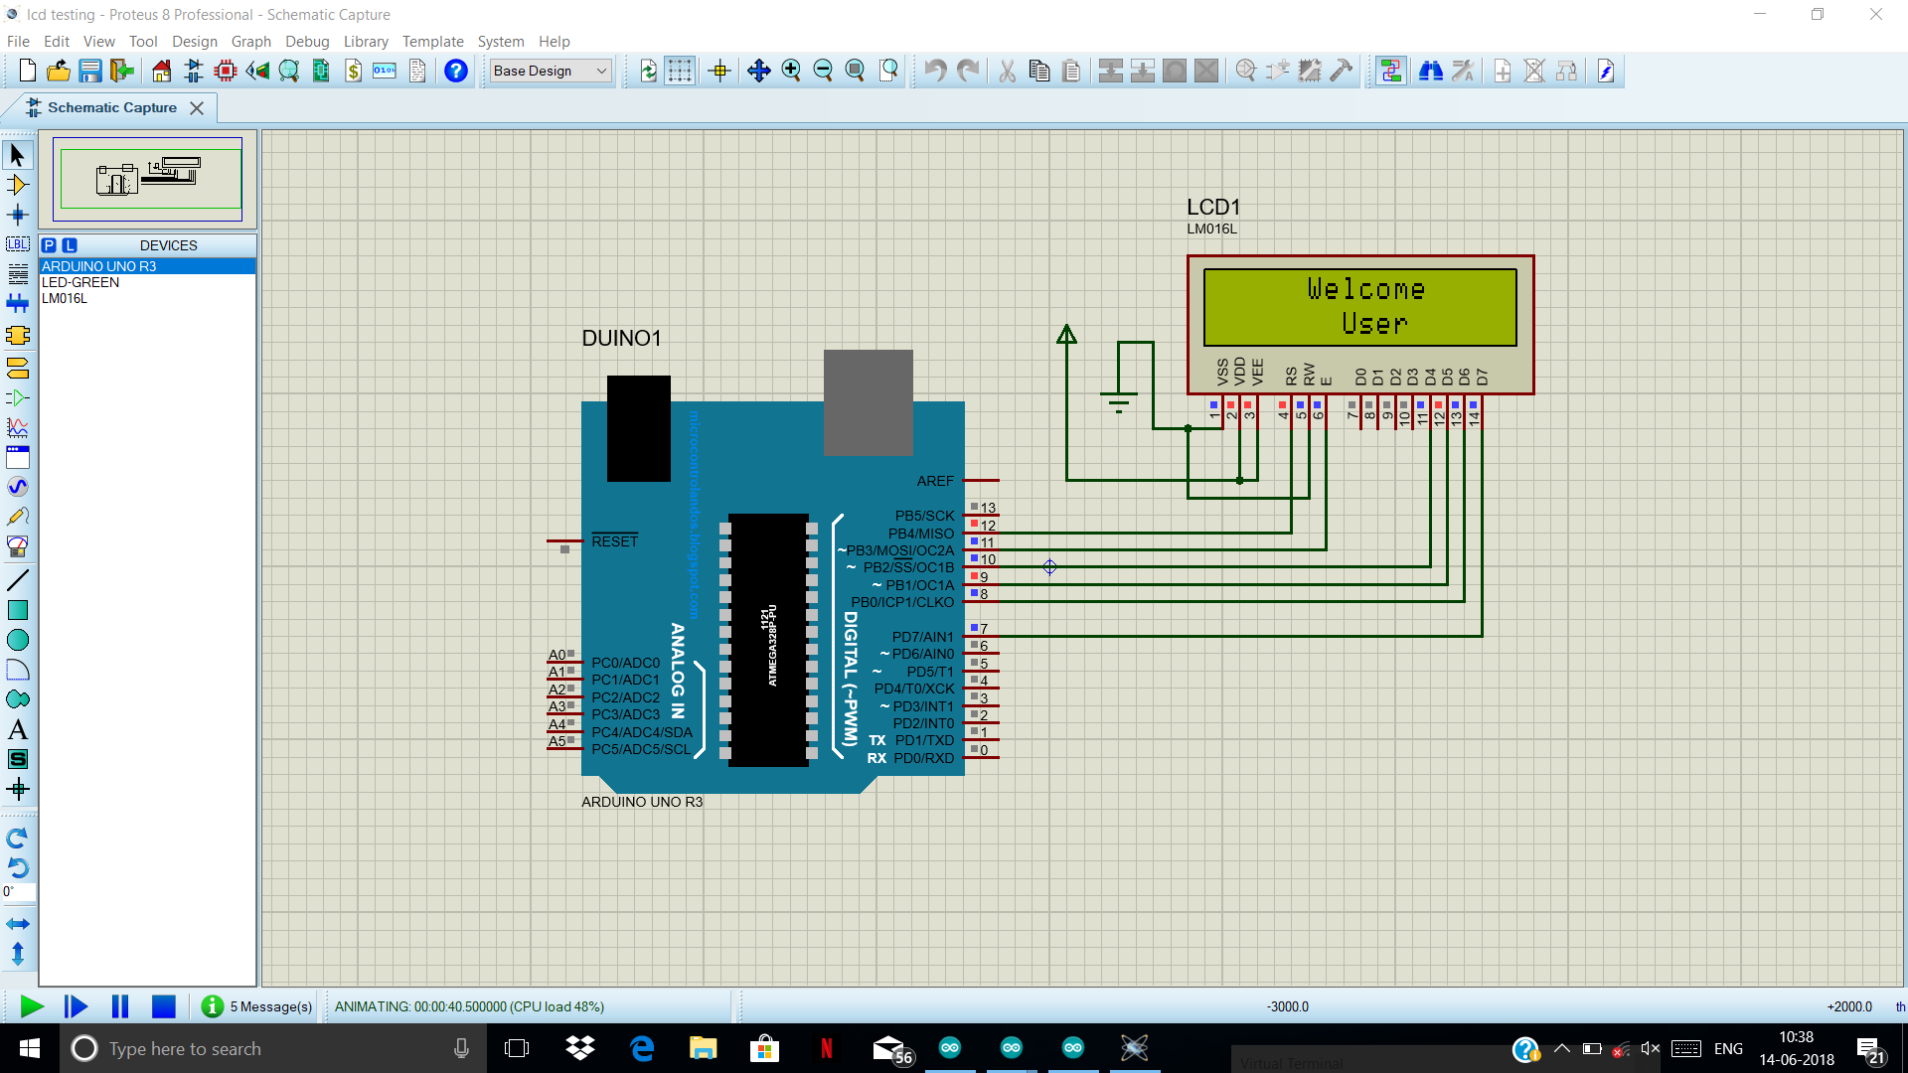

Testing for LCD

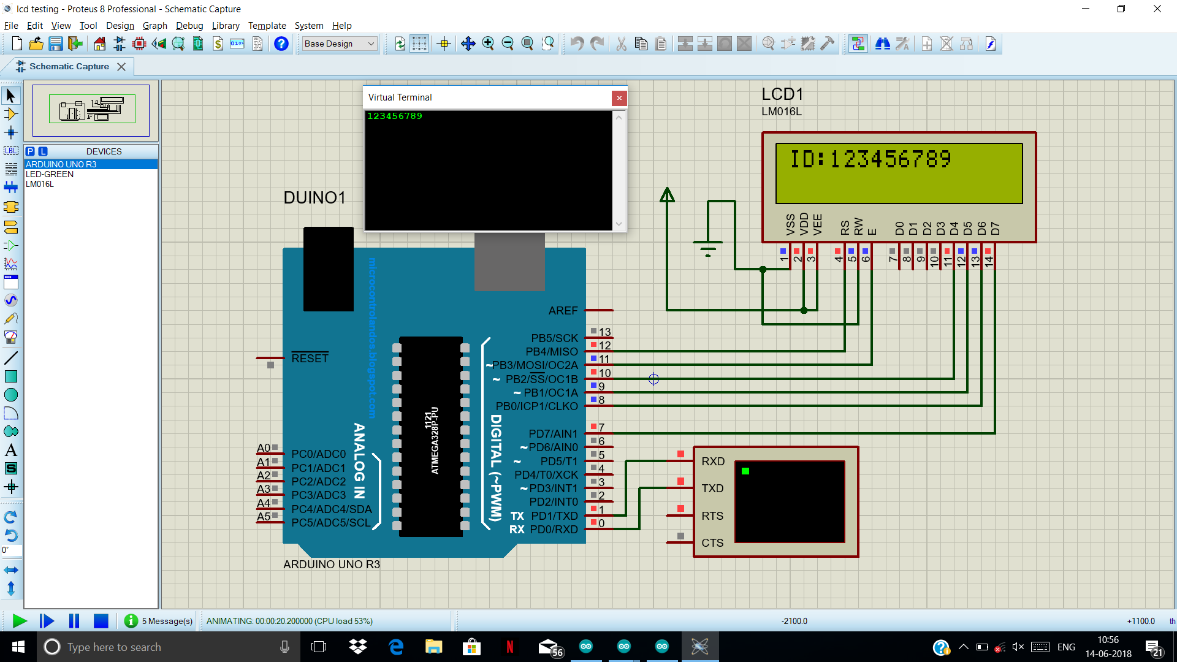

Testing of RFID reader

15 **CONCLUSIONS**

This project can prove to be an asset in every field where attendance is taken as it provides an easiest and innovative way of taking attendance this project not only take attendance but also excites the students to know the logic being used in all this working. It also takes the student to a new level of technology. Its accuracy is far better than taking attendance manually. Teachers can make mistake while taking attendance through this device it can never be wrong. At last we want to conclude that This is a better way of taking attendance. The best part is that the names of absent student are sent to the mentor or the HOD via app which saves the time. The objective was to build an open source-based RFID Attendance Management system which enhance the performance and efficiency was successfully achieved. Data temping is not possible. The system built is flexible, cost effective due to use of open source software and can be extended by adding more modules.

16 **PROJECT LINKS**